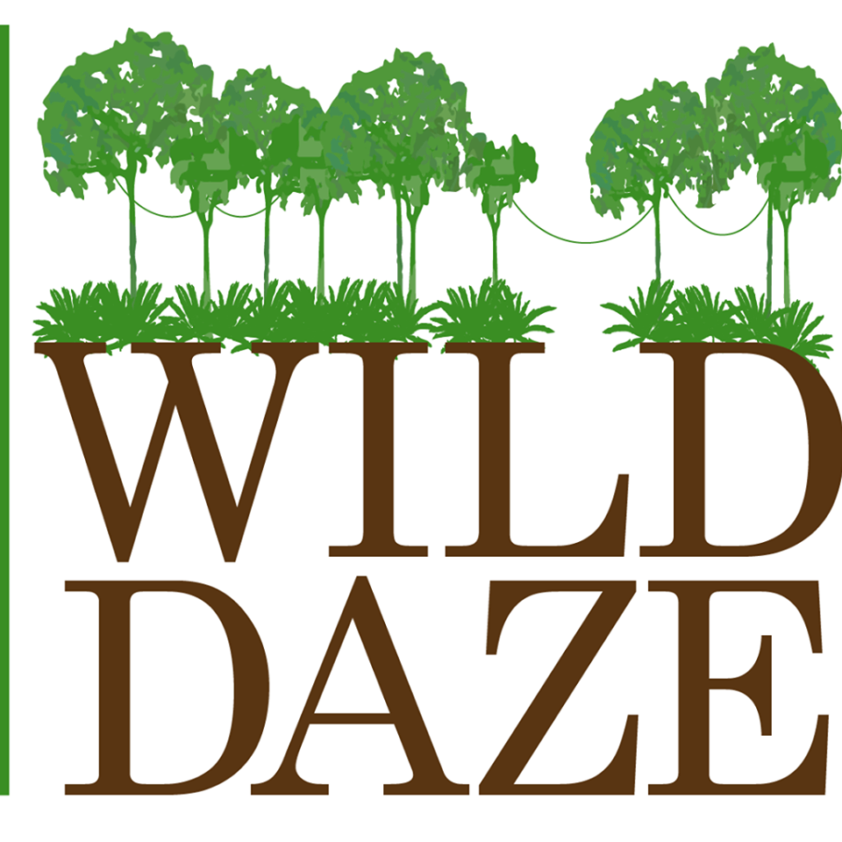

Light Productions and Cinedigm announce the release of a glorious documentary ***WILD DAZE,*** debuting Friday, September 18 until October 25, 2020 on nine Virtual Cinema showcases. Since these unprecedented times called for new alliances and though this new film would have been shown live in theatres were it not for the mandatory pandemic closures, **the filmmaker partnered with eleven independent cinemas to virtually debut.**

***WILD DAZE*** is a very timely documentary, which examines the threats facing African wildlife and indigenous forest peoples, including rampant corruption, deforestation, bush meat trade and an exploding human population. But ***Wild Daze*** will also utterly immerse audiences into a wild world that Stuart beautifully captured on the vast African continent.

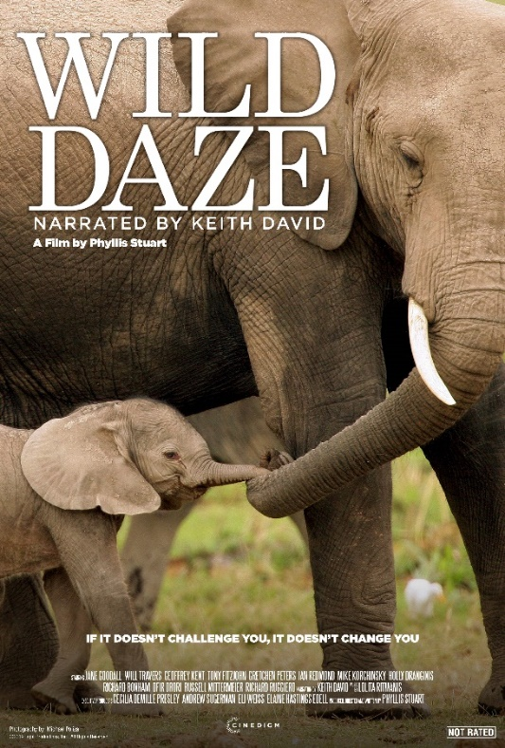

Created by director, writer, producer **Phyllis Stuart**, narrated by 3X Emmy Award-Winning actor **Keith David** and scored by Emmy winner Lolita Ritmanis, **WILD DAZE** premieres in a virtual cinema release **Friday, September 18** and runs through **October 25h**.

Five years in the making and filmed across 9 countries, the feature-length documentary ***WILD DAZE***depicts the dire threats facing African wildlife. Since human beings are dependent on nature when we work to save nature and non-humans, we are really working to save ourselves. This powerful cinematic call to action demonstrates the dire challenges facing species who depend on biodiversity, including our own.

Through interviews with conservation experts ranging from Dr. Jane Goodall to wildlife trophy hunters, filmmaker Phyllis Stuart explores the relationship between international crime cartels, colluding government officials, animal poaching, the illegal ivory trade, cattle barons and human beings, as she examines how rampant corruption complicates the fight to save species nearing extinction. Since human survival hangs in balance, we must decide whether we see ourselves as superior, entitled consumers or as a part of a delicate ecosystem. In the film. Dr. Jane Goodall establishes the existential crisis when she says: *“How come that the most intellectual species to ever walk the planet is wiping out the other life forms, is destroying ecosystems? Because this in the end is going to lead to our destruction. So, we destroy these animals at our own peril without thinking of the future of our own species.”.*

**Synopsis: *WILD DAZE*** If It Doesn’t Challenge You, It Can’t Change You. This fast-paced and richly stitched documentary, employing mesmerizing visuals driven by **Keith David’s** commanding narration, and fueled by dozens of engaging experts like **Jane Goodall, Andrea Crosta, Will Travers** and **Azad “Oz" Ebrahimzadeh**, trophy hunters and displaced indigenous African forest peoples. Filmmaker Phyllis Stuart created the profound documentary film ***WILD DAZE*** to reveal the unvarnished truth about our tenuous relationship with nature and underscore an urgent need to end the ecocide. While ***WILD DAZE*** captivates audiences as they journey across the glorious African continent, viewers will also understand why its precious natural resources are vanishing. This crisis is driven by unbridled crime and corruption, armed insurgents, trophy hunting, the illegal pet trade, the bush meat trade and an insatiable consumer demand for natural resources. Moreover, international criminal cartels orchestrate the illegal wildlife trade while destroying rural societies as it generates twenty billion illicit dollars each year. Not only are wild animals being driven to the brink of extinction, (a loss that threatens all human health), but the indigenous Africans living with the wildlife are being exploited, killed or displaced.

Find tickets here:

**Virtual Cinema Event: https://watch.eventive.org/wilddaze**

Cinedigm will release Wild Daze on Digital and DVD on October 27, 2020.

Press & Media Inquires Contact:

Anderson Group Public Relations [agpr@andersongrouppr.com](mailto:agpr@andersongrouppr.com)