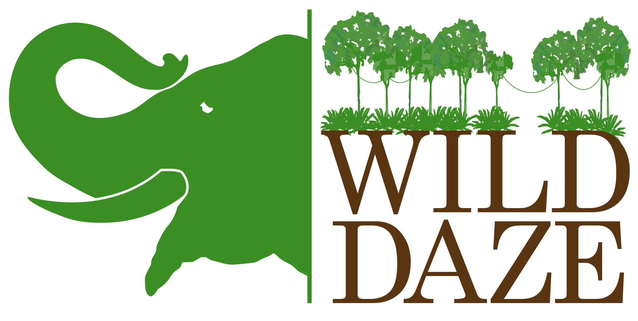
If It Doesn't Challenge You
It Doesn't Change You
Wild Daze is a new feature-length documentary forged by a fierce desire to save the African wildlife, while also protecting its exploited women, children and forest peoples.

An astonishing look at the complex threats which humans impose on Africa's vanishing wildlife, Wild Daze undeniably demonstrates how their loss affects the entire planet. ​

Set in Sub-Saharan Africa, in her compelling documentary, Wild Daze, director and producer, Phyllis Stuart shares the unvarnished truth about the battle between human’s desire to control nature and our need to save the wild. ​

Rife with brilliant activists and conservation experts, Stuart dives into crime, hunting, deforestation, the bush meat trade and earth's fastest growing human population. Stuart captured a wide range of exhilarating and terrifying stories from wildlife activists who, for decades, have navigated harrowing social practices and systemic corruption to save the wild.​ Although independently created, Wild Daze has enjoyed support from esteemed cast like: Dr. Jane Goodall, Will Travers, Ofir Drori, Tony Fitzjohn, Richard Bonham, among others.

Employing mesmerizing visuals captured by brilliant wildlife photographers and seasoned cinematographers, aided by powerful narration from Emmy-winning actor, Keith David, and bolstered by a bold musical score from Emmy-winning composer, Lolita Ritmanis.

​Wild Daze wades rapt (and at times shocked) viewers ever so gently through Africa’s murky complicity to reveal how human activity takes a huge toll on the wild. Saving the Congo basin rainforest and its precious biodiversity helps everyone. If we don't protect this forest, we can never abate climate change. ​
​
While human beings are tied to animal welfare in ways both ethical and existential.
Wild Daze audiences also see how saving the wild is as much about helping people as it is about protecting nature. Because human beings are dependent on nature when we work to save nature, we are really working to save ourselves. Since human survival hangs in the balance, we must decide whether we see ourselves as superior, as custodians, as entitled consumers or as a part of a delicate ecosystem.

Most people don't realize African wildlife is facing extinction, but believe Africa is still a massive frontier teeming with wildlife and is largely devoid of humans. The truth is we have lost 83% of wild mammals and 50% of plants in the past forty years. ​​

